REST API

For CURD Operation on Tasks

1. Add task

a. End Point: URL=http://<<IP>>/restapi/task/add

b. Request JSON:

{
"status": "Complet",
"name": "Mount",
"priority": "High"
}

c. Method : POST
d. Accept : application/json
e. Content Type :application/json

e.g

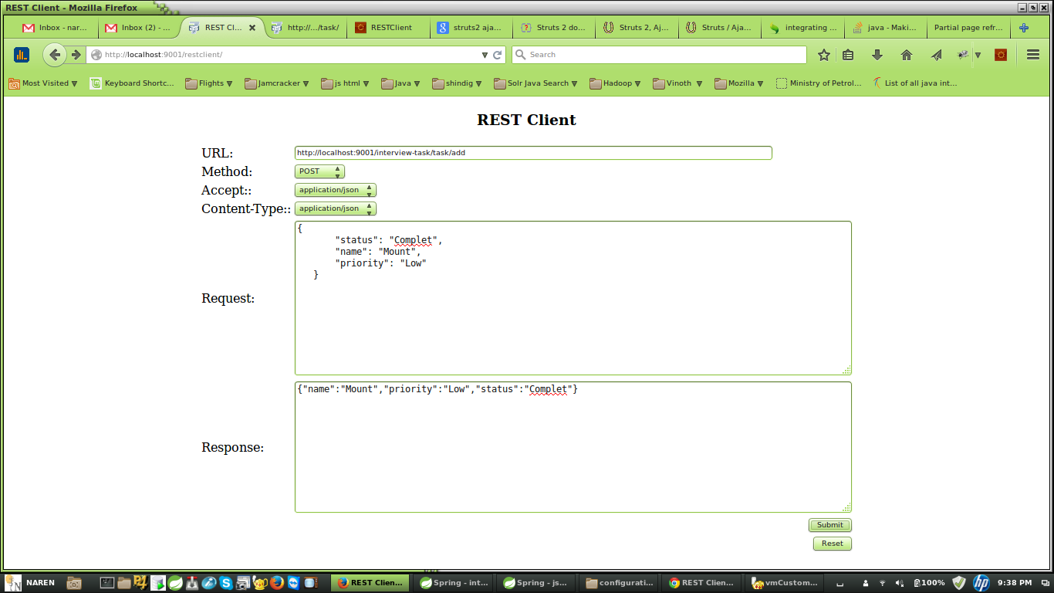

2. Delete task

a. End Point: URL=http://<<IP>>/restapi/task/delete/{name}
b. Method : DELETE
c. Accept : application/json
d. Content Type :application/json

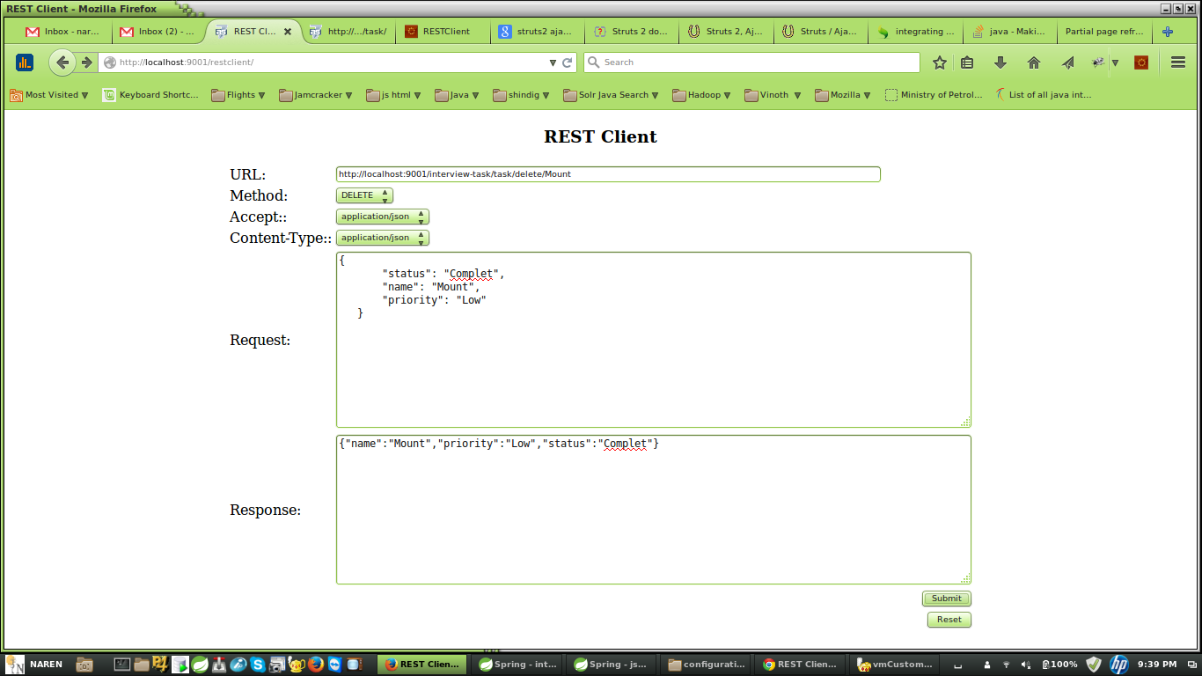

3. Update task

a. End Point: URL=http://<<IP>>/restapi/task/update

b. Request JSON:

{
"status": "Pending",
"name": "Mount",
"priority": "High"
}

c. Method : PUT
d. Accept : application/json
e. Content Type :application/json

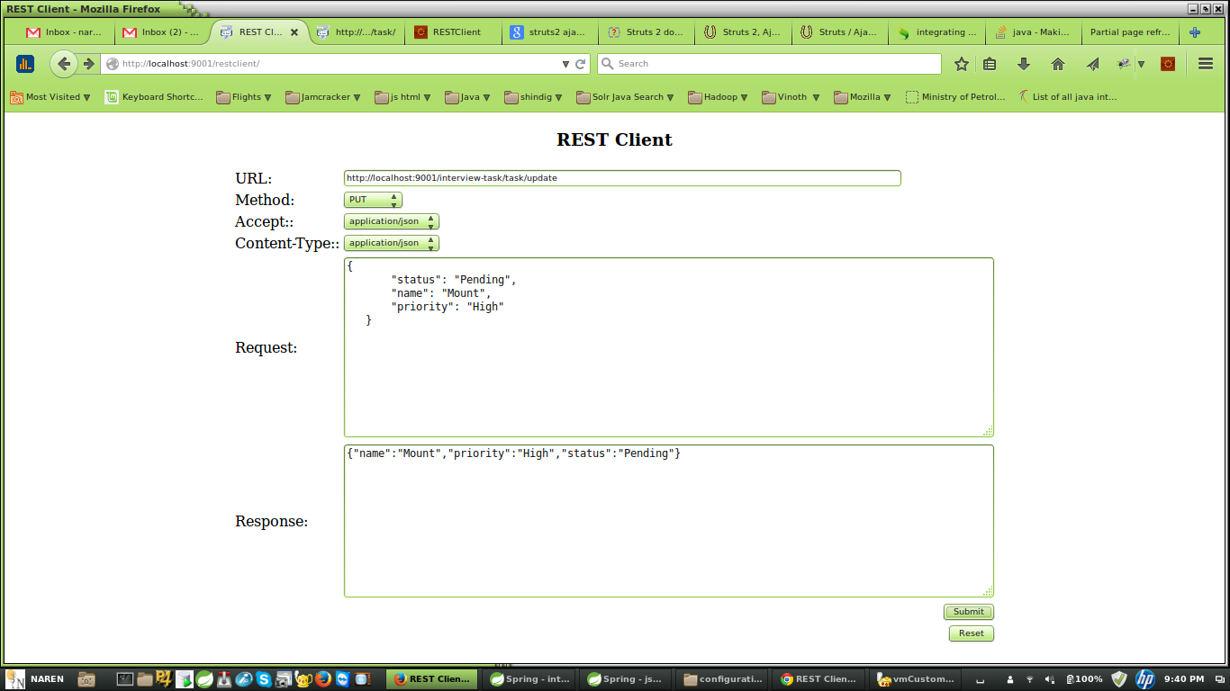

4. Search task

a. End Point: URL=http://<<IP>>/restapi/task/search?name={name}
or http://<<IP>>/restapi/task/search?status={status}
or http://<<IP>>/restapi/task/search?priority={priority}
b. Method : GET
c. Accept : application/json
d. Content Type :application/json

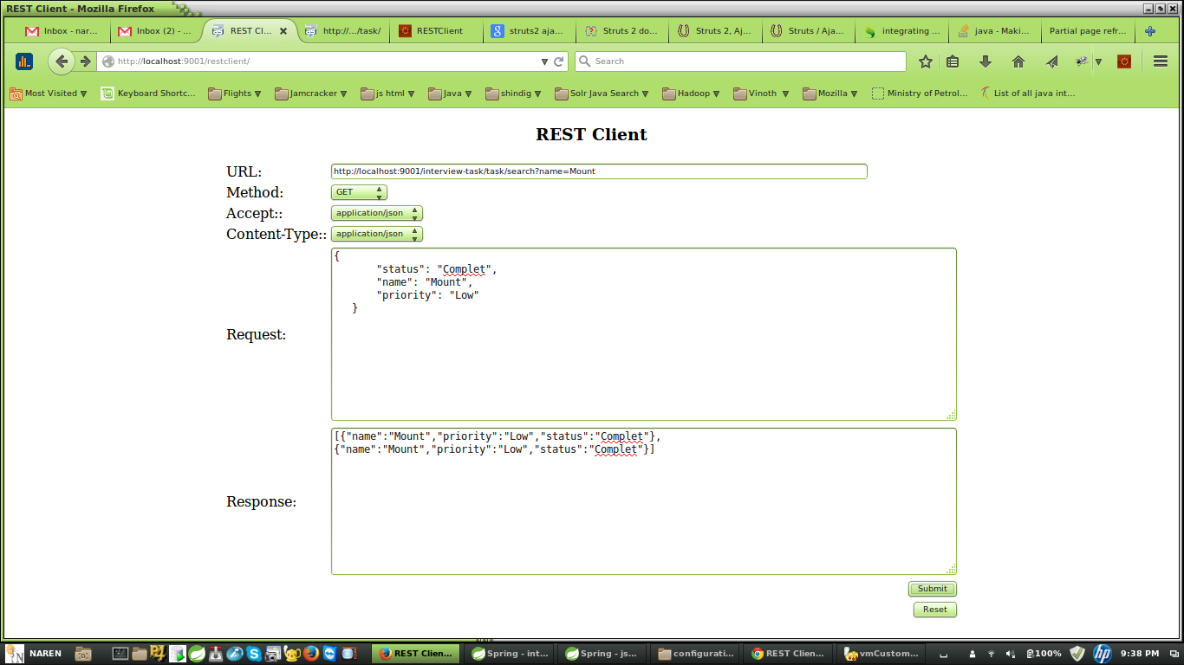

5. List All Task

a. End Point: URL=http://<<IP>>/restapi/task/
b. Method : GET
c. Accept : application/json
d. Content Type :application/json

